**Patriotic Quilt Raffle**

**$5.00 for 5 tickets**

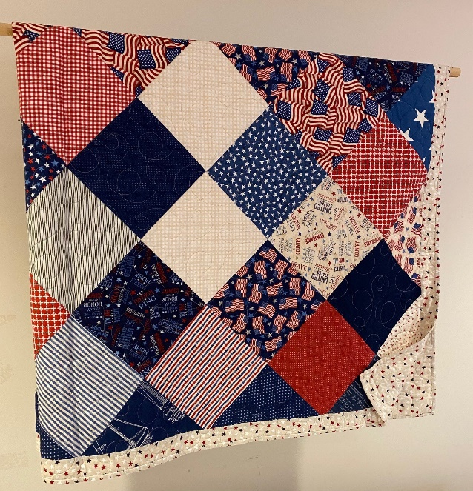

**Drawing held on September 1, 2024 after Mass**

**You do not need to be present to win**

**Donated by Jonita Masson**

**Proceeds to go towards a new nativity set**

