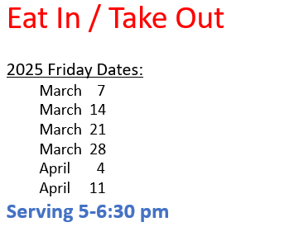

**All profits donated to various charities that the Knights of Columbus Council 9303 support.**