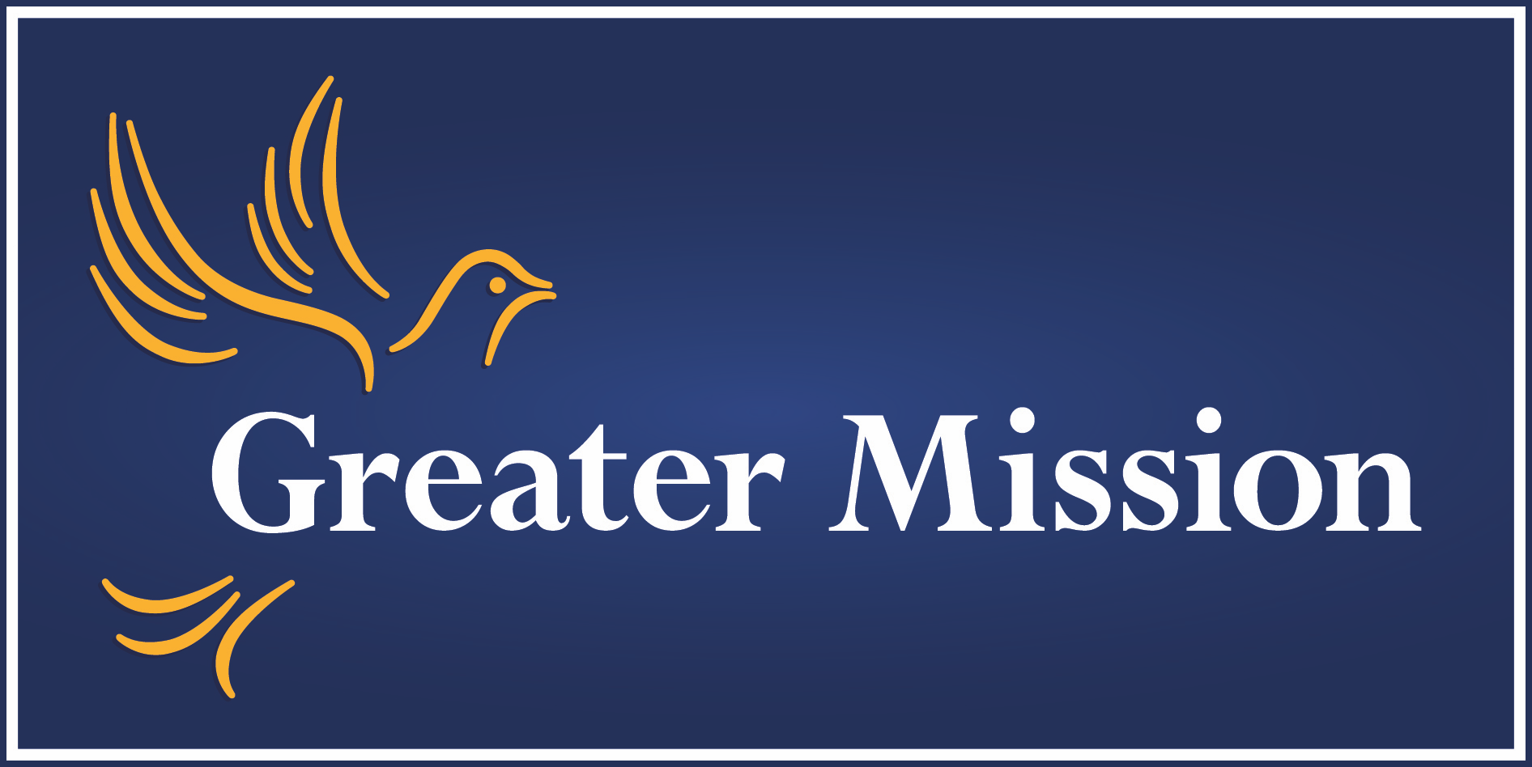

Announcing Our Feasibility Study

Over the next few weeks, St. Peter the Apostle parish will be conducting a professionally executed and confidential Feasibility Study to determine if we can conduct a capital campaign to raise funds to support a renovation project of our parish facilities. The Feasibility Study will test support for our case for fund-raising as was explained recently at Mass by the ZMM architectural firm and the potential timetable for a campaign. The Feasibility Study process includes confidential one-on-one interviews, a parish Town Hall meeting, and an online survey. The Final Study Report will provide our parish leadership with the information we need to make a prudent and informed decision on what next steps should be taken.

Greater Mission, a Catholic development services firm, is conducting the feasibility study over the next several weeks. The data they gather will be confidential and reported to us in an aggregate report of input and opinion. Greater Mission will provide professional recommendations on next steps. An Executive Summary of the Study Report will be published in the parish bulletin and a full copy of the report will be posted on the parish website so that there is full transparency about the Feasibility Study results.